[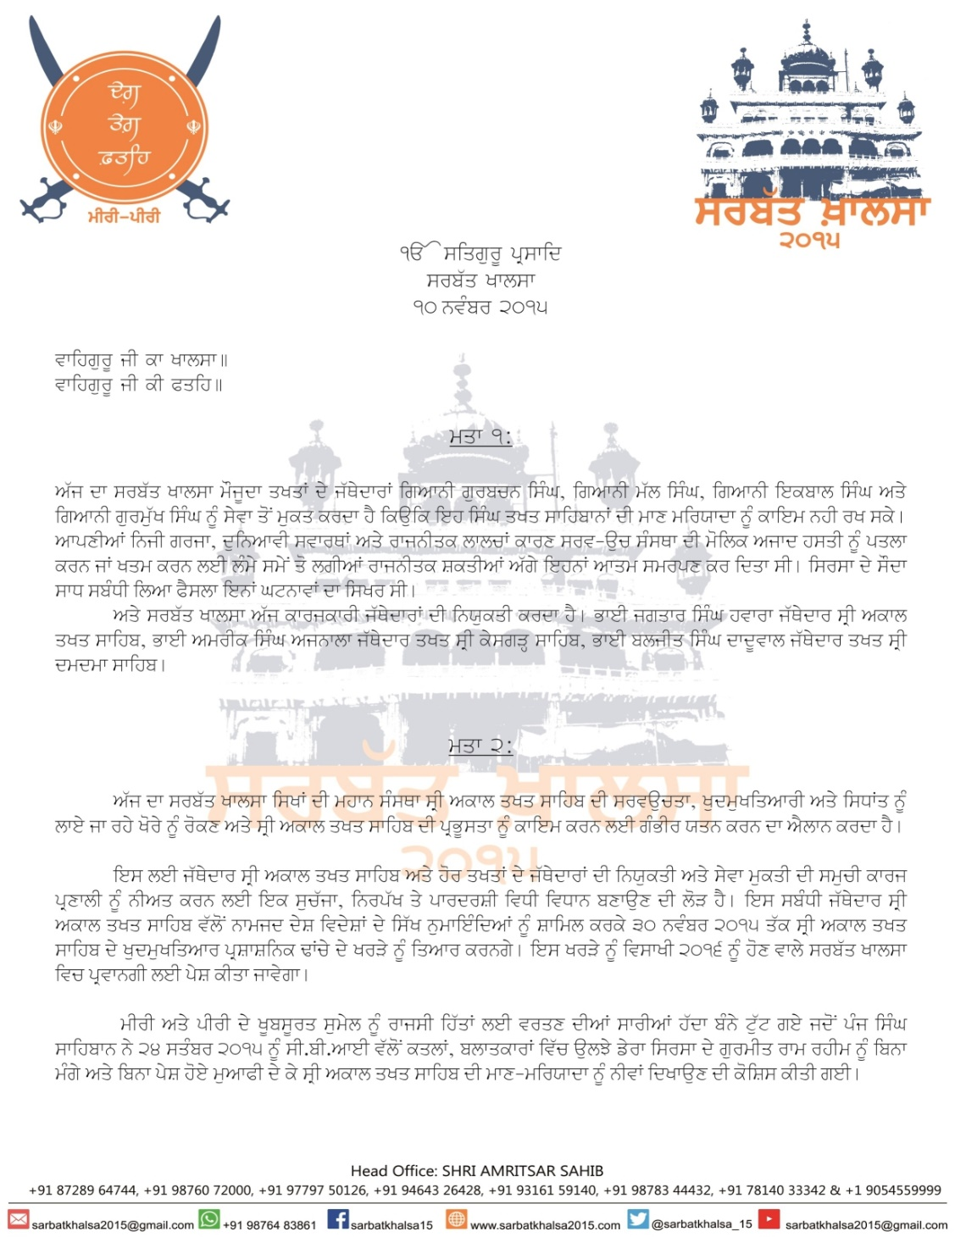](https://www.sikh24.com/wp-content/uploads/2015/11/sarbatkhalsa_2015-5.jpg)

**gurmqy dw audyS:**

ATwt swlW dw swfw ieqhws zulmW nwl BirAw hoieAw hY [ AzwdI qoN bwAd AsIN ies dyS nwl iksmq joVky AwpW pCqw rhy hW [ 13 ApRYl 1978 qoN surU hoieAw vrqmwn sMGrS, sMq jrnYl isMG, BweI AmrIk isMG, bwbw Qwrw isMG, jnrl SubyZ isMG smyq AwpW hzwrW isMGW nUM AwpW srDWJlIAW id`qIAW Aqy styj qoN vI ieh AYlwx kIqw ‘qy pRx kIqw ik ieh ShwdqW is`K rwj leI hn, Azwd is`K rwj leI hn [ jy auhnW isMGW nUM s`cIAW srDWjlIAW dyxIAW cwhuMdy hW qW idRVHqw dy, AnuSwsn dy Aqy eykqw dy nwl asIN Awpxw sMGrS jwrHI r`KWgy[ dusry mqy swDsMgq jI pyS kIqy jw rhy hn:

[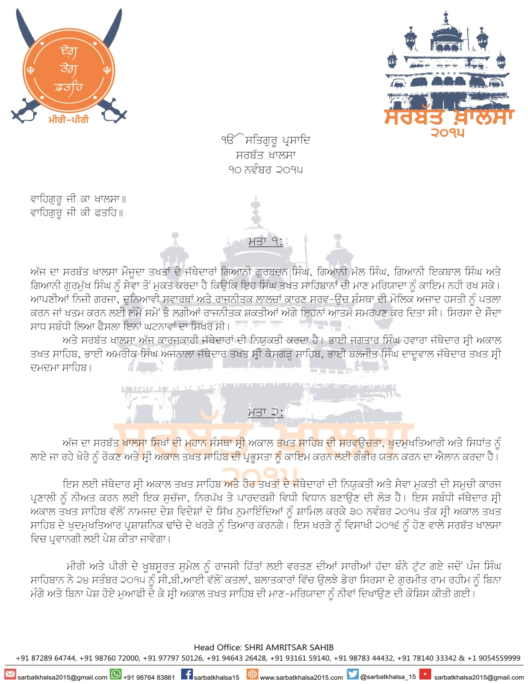](https://www.sikh24.com/wp-content/uploads/2015/11/sarbatkhalsa_2015-5.jpg)

[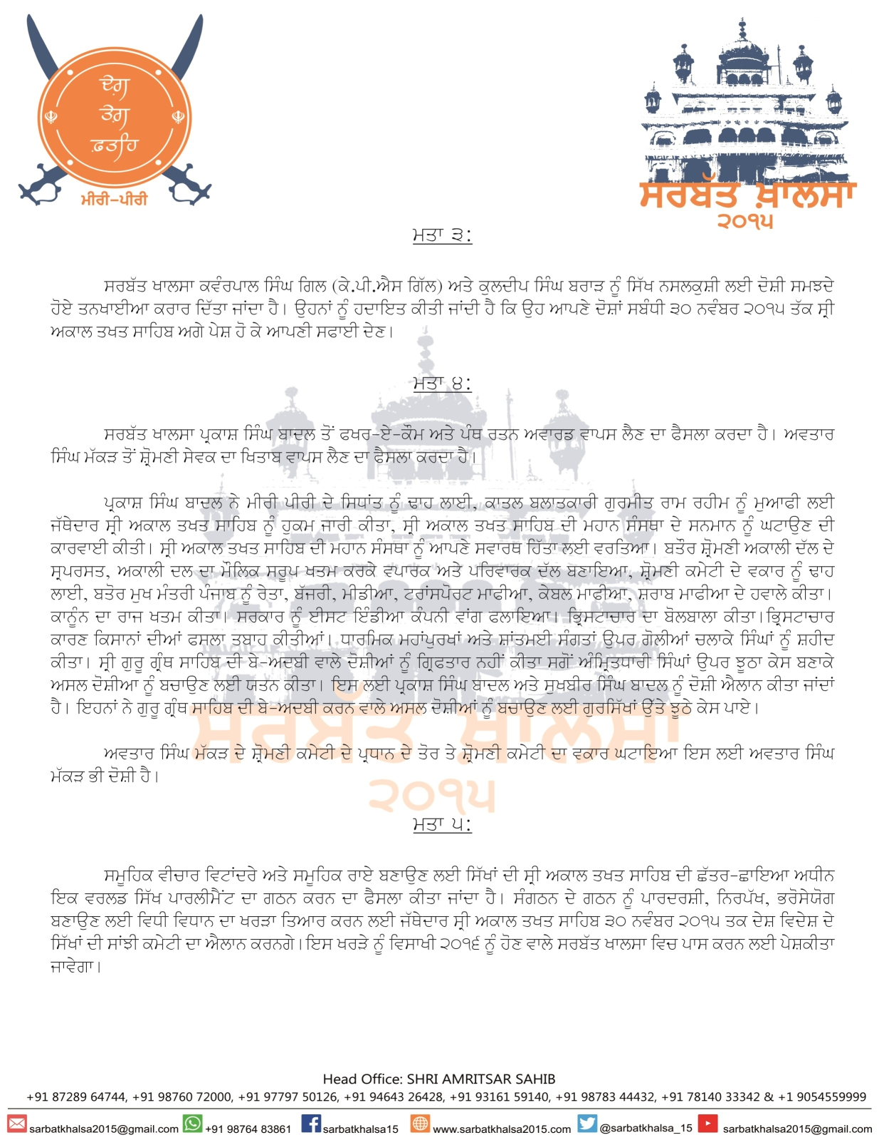](https://www.sikh24.com/wp-content/uploads/2015/11/sarbatkhalsa_2015-6.jpg)

[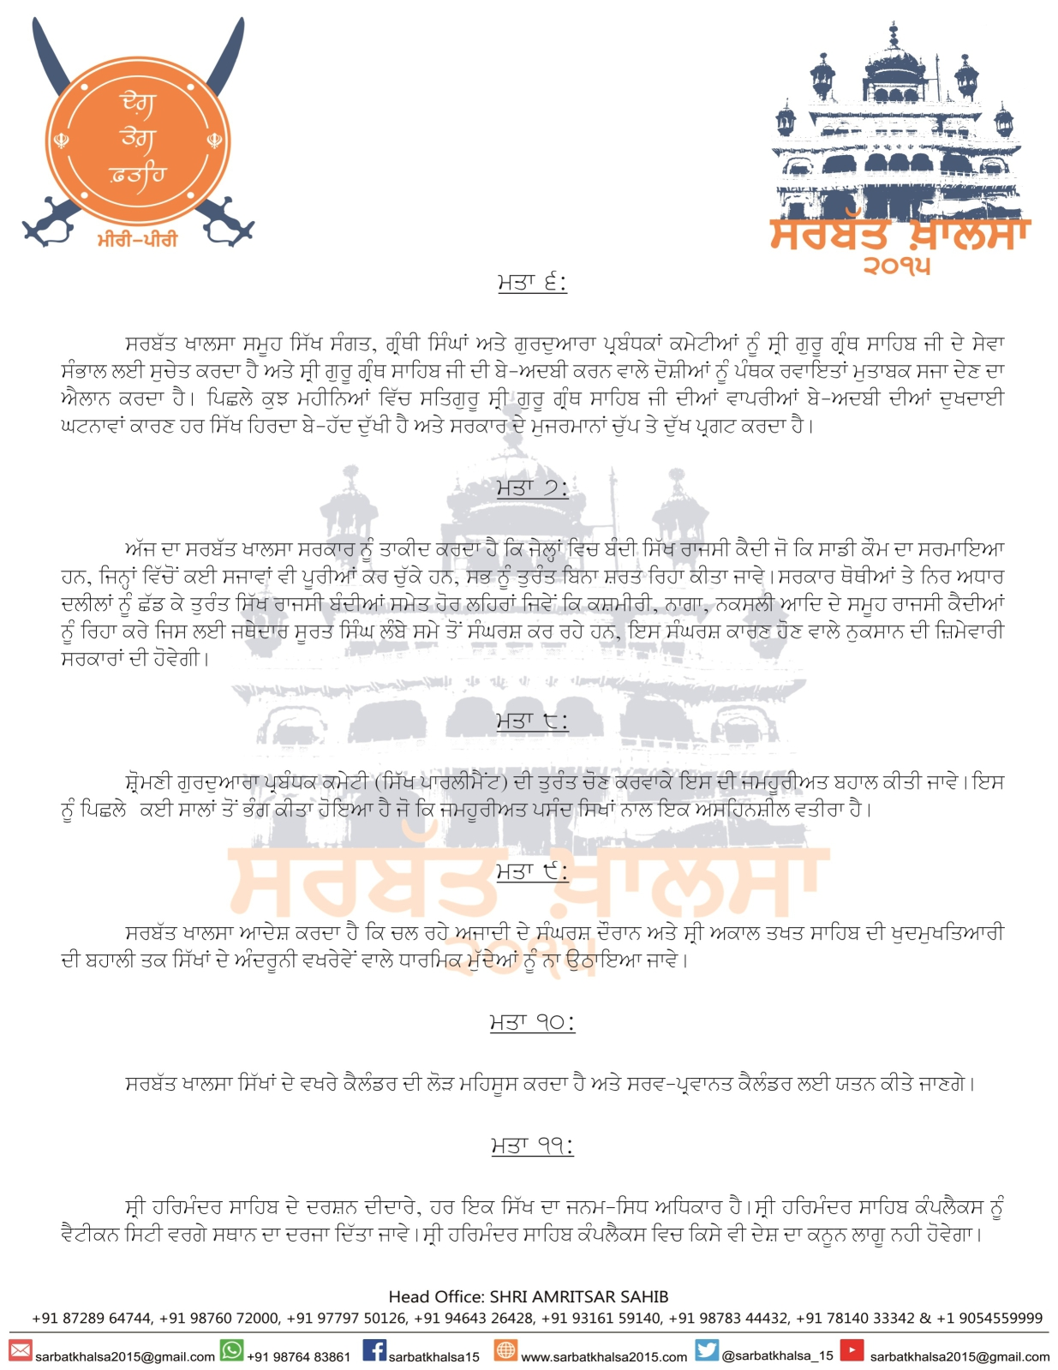](https://www.sikh24.com/wp-content/uploads/2015/11/sarbatkhalsa_2015-7.jpg)

[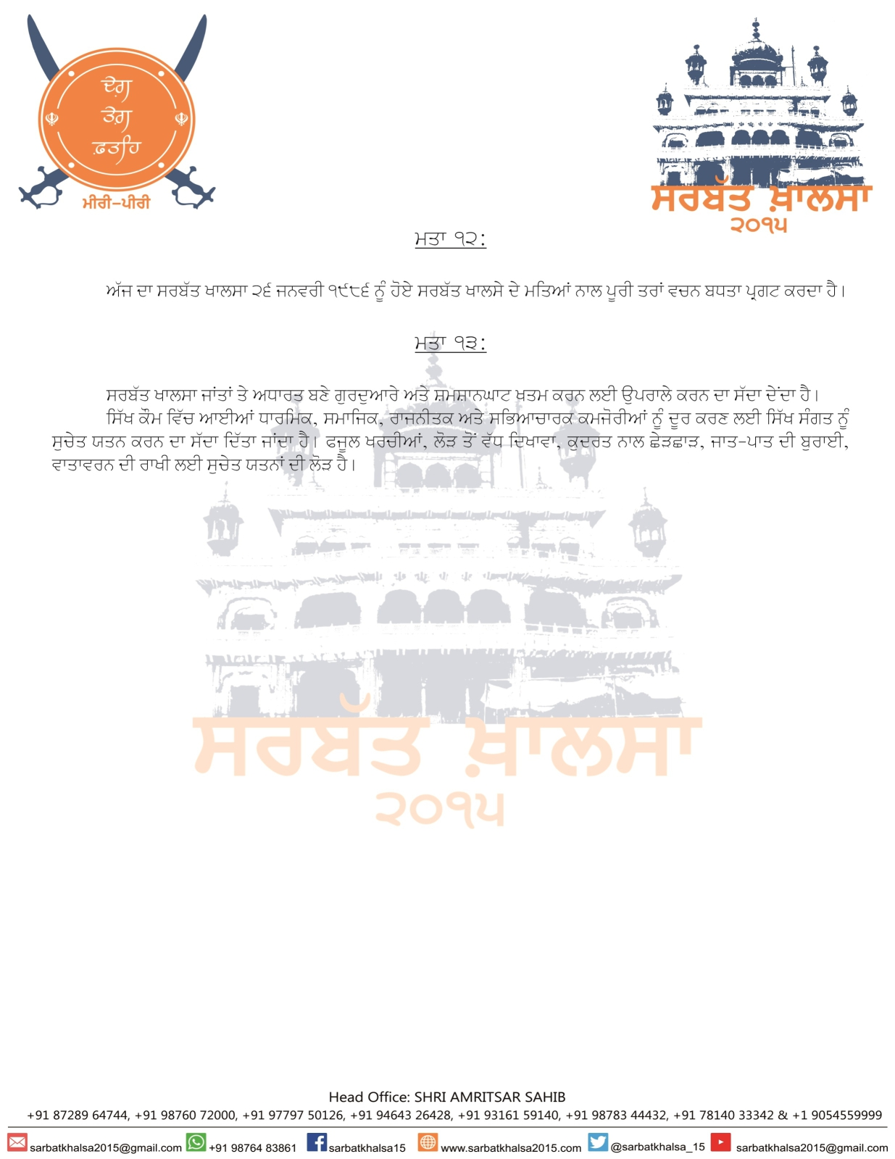](https://www.sikh24.com/wp-content/uploads/2015/11/sarbatkhalsa_2015-8.jpg)

Preamble

Our recent history of the past 68 years since Indian independence has been one full of such brutality that we rue the day that our fate was joined with this country. Since the 13th April 1978 when the present struggle began, Sant Jarnail Singh, Bhai Amrik Singh, Baba Thara Singh, General Shabegh Singh and thousands of Sikhs have been honoured by the Sikh Nation, and we hereby clarify that these martyr’s died for the establishment of a Sikh Raj, a free Sikh Raj. Our tributes will only ring true if we maintain our struggle with steadfastness, discipline and unity. Other resolutions now follow.

Resolutions

[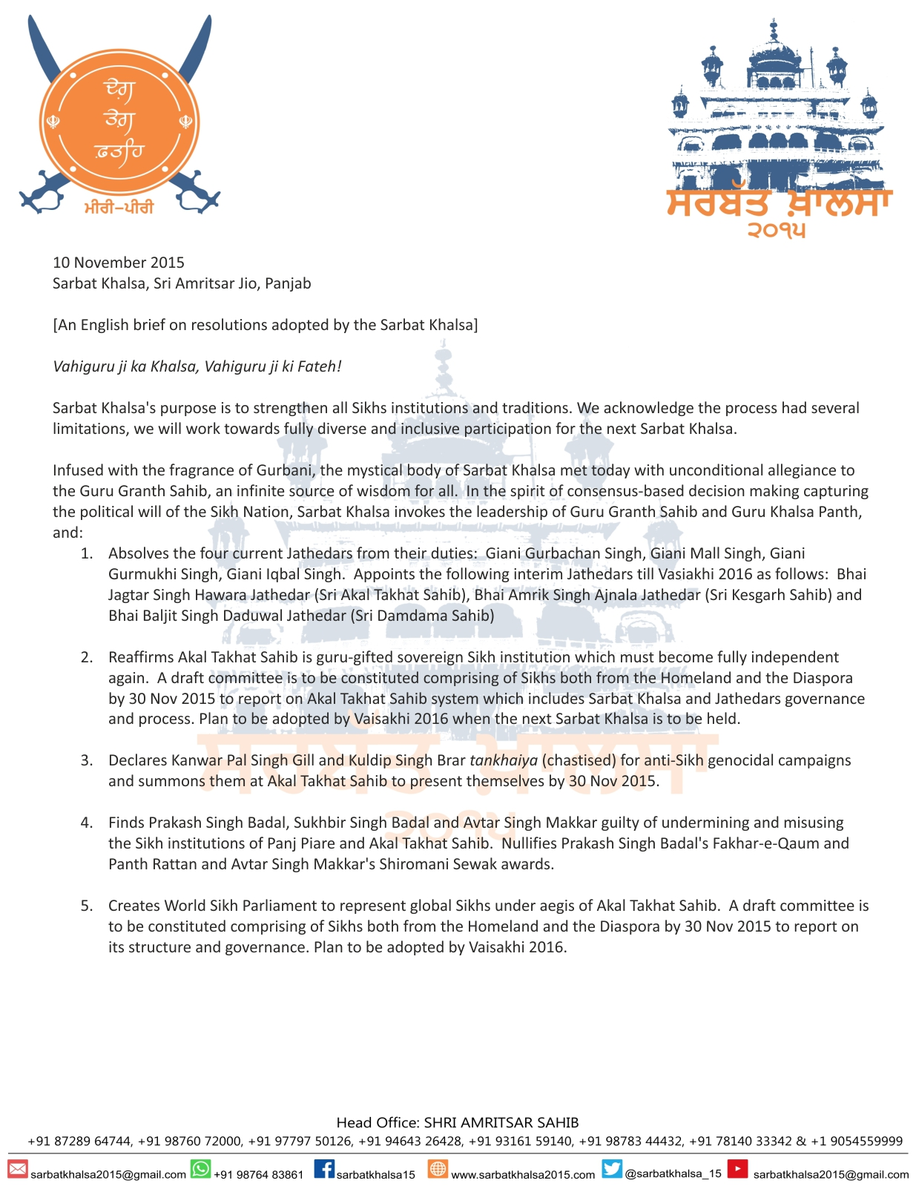](https://www.sikh24.com/wp-content/uploads/2015/11/sarbatkhalsa_2015-9.jpg)

[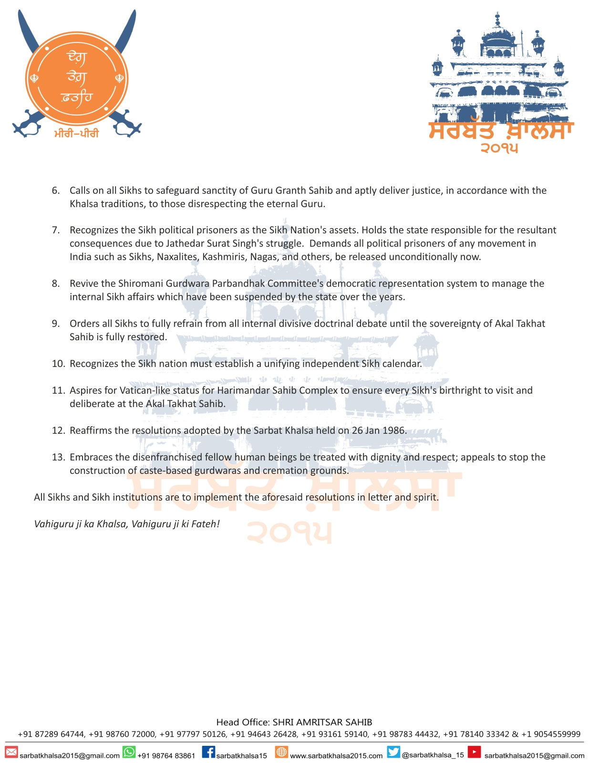](https://www.sikh24.com/wp-content/uploads/2015/11/sarbatkhalsa_2015-10.jpg)